Press and Seminar on Green Book for Rural Areas:
Analysis and Forecast on China’s Rural Economy
(2013-2014)

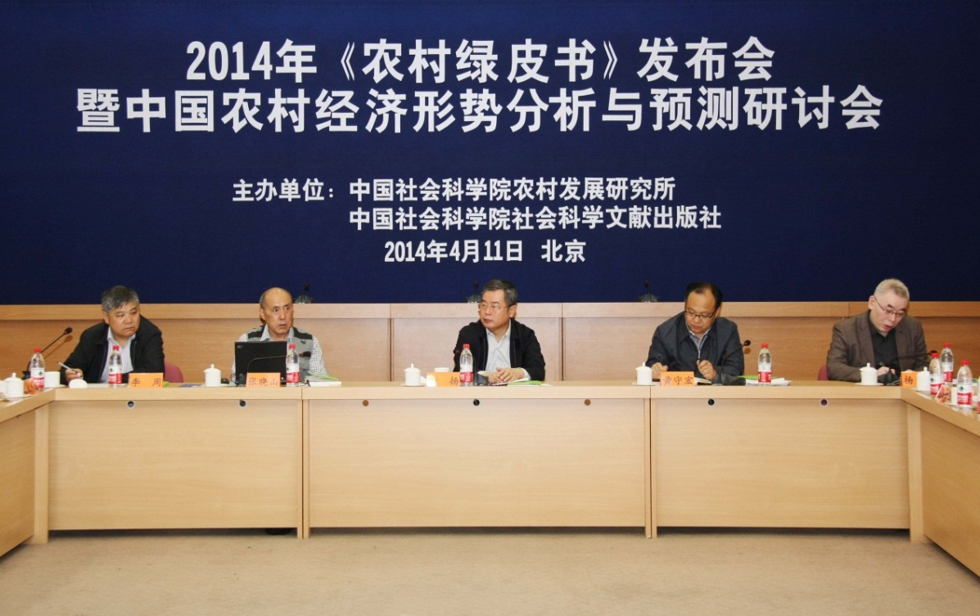
The Press and Seminar was held on April 11, 2014.

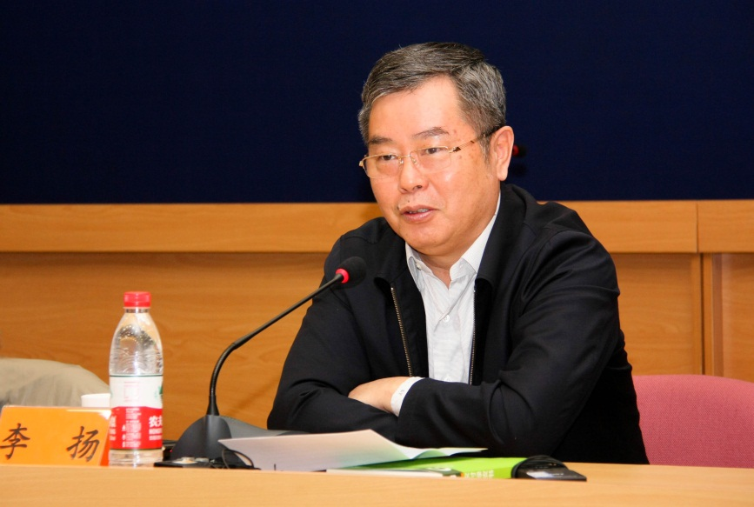
Mr. Li Yang, Vice President of CASS made an address.
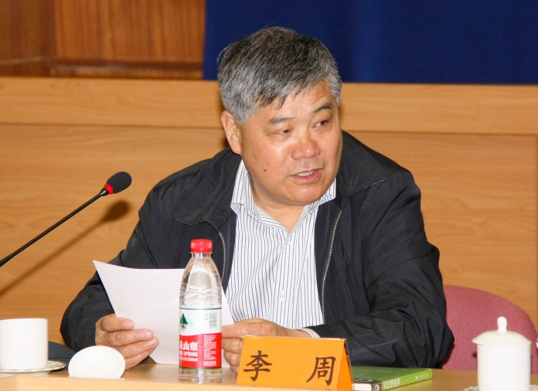
Mr. Li Zhou, Director of RDI hosted the Press and Seminar.

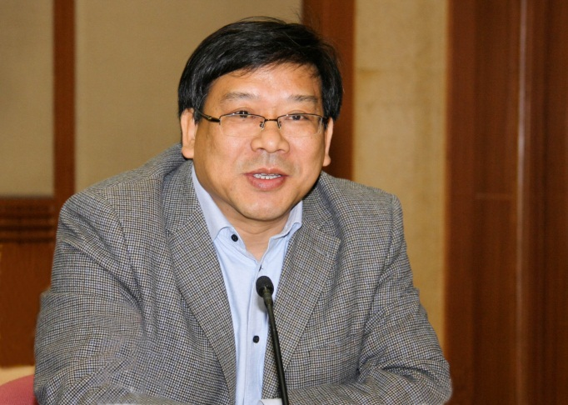Prof. Du Zhixiong, Deputy Director, RDI, CASS
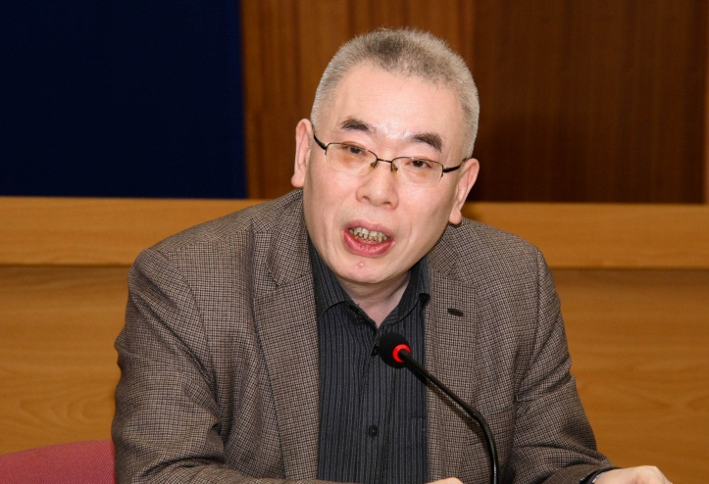
Prof. Yang Qun, the publisher

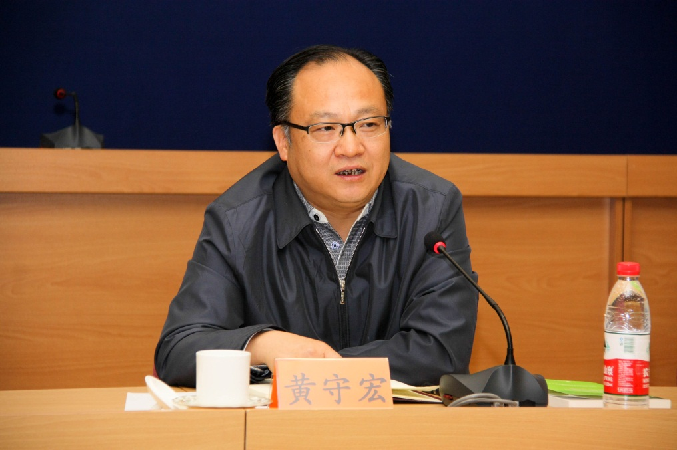
Mr. Huang Shouhong, Vice Minister of Research Office of the State Council

Mrs. Fang Yan, NDRC

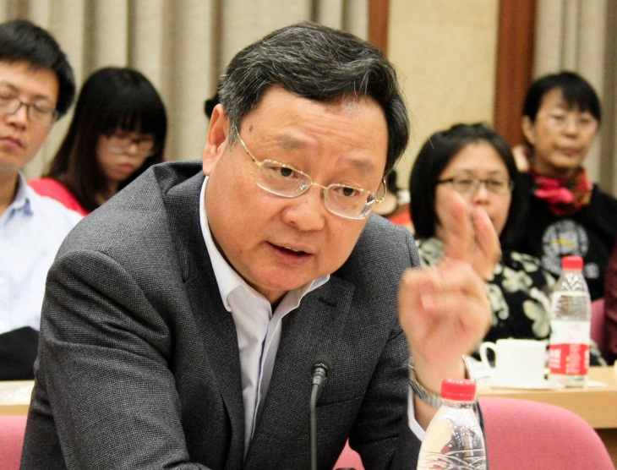
Mr. Zhang Hongyu, MOA

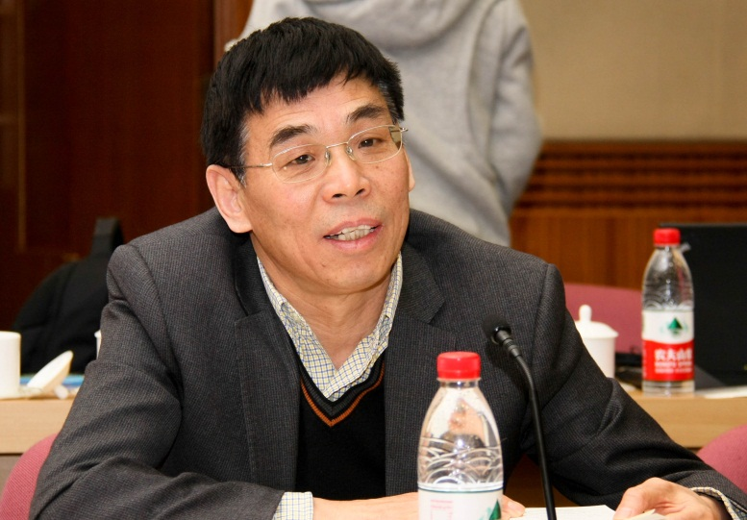
Mr. Song Hongyuan, Research Center of MOA

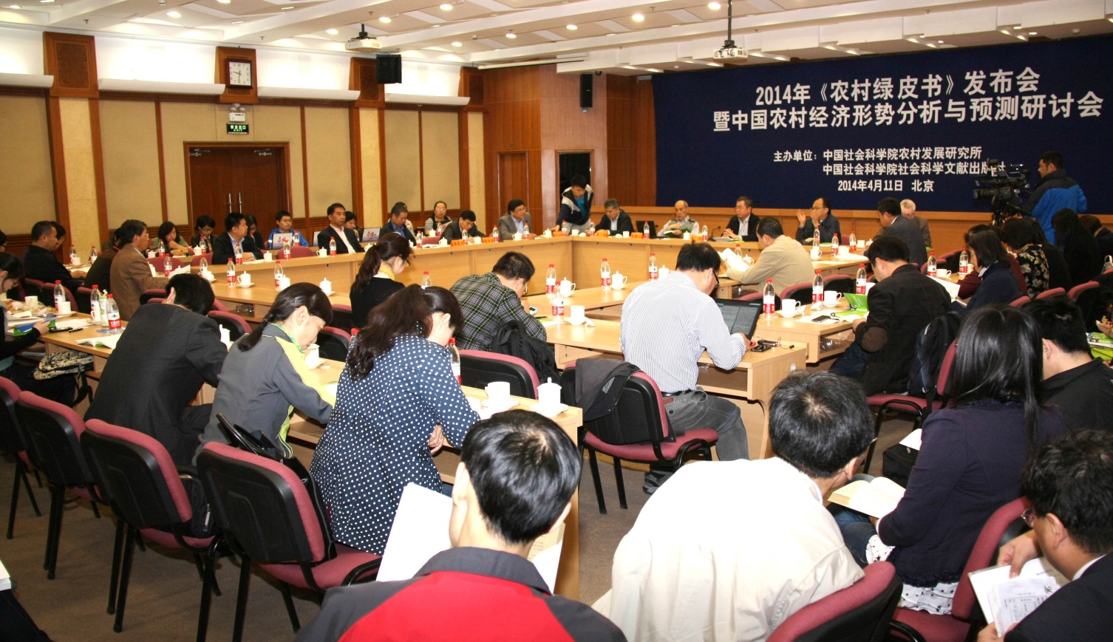
A view of the Press and Seminar.

