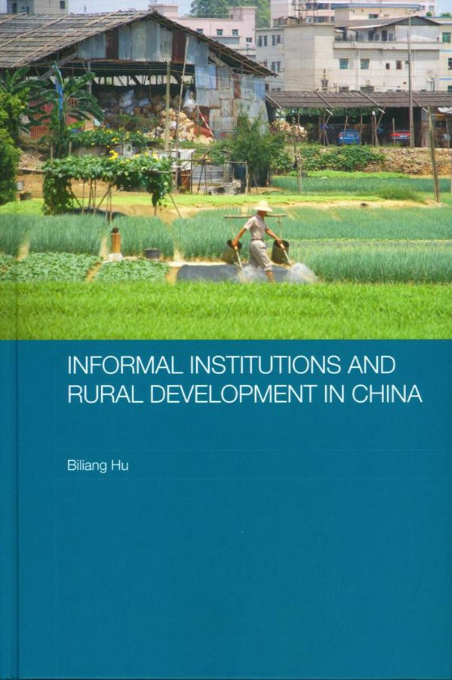

INFORMAL INSTITUTIONS AND RURAL DEVELOPMENT IN CHINA

Biliang Hu
Routledge
July 2007
Biliang HU is Professor of Economics at the Graduate School of the Chinese Academy of Social Sciences and Senior Research Fellow of the Academy’s Rural Development Institute．He received his Doctorate of Economics from the School of Economics and Management, Witten／Herdecke University in Germany．His main academic interests are in institutional analysis in relation to village governance and rural development．

Abstract
China’s successful transition from a centrally planned economy to a socialist market economy, with rapid growth in rural areas since the early 1980s，is a consequence of the impact of both formal and informal institutions．Hitherto, most work undertaken on this issue has focused on formal institutions．This book shows the great importance of informal institutions on the economic and social development of rural China．It examines the relationship between informal institutions and rural development in China since the end of the 1970s，focusing in particular on three major informal institutions：village trust and rotating savings and credit associations (ROSCAs)，guanxi community, and‘integrating village with company’(IVWC) governance．It argues that informal institutions，traditions and customs are a11 critical factors for facilitating modernization and social and economic development，enabling the integration of trust，reciprocity, responsibility and obligation into economic and social exchange processes, and considerably lowering risks and transactions costs．It does this by analysing case studies that illustrate how informal institutions function and support development in rural China．

Praise for Informal Institutions and Rural Development in China
Dr Biliang Hu’s book provides valuable insights into how rural development at the village 1evel actually worked in China when market distortions were gradually removed from the late 1970s．His in-depth empirical work helps US understand better how traditional governance structures in rural China, spontaneous cultural adaptations and the rise of informal local institutions such as village credit associations, reinforced the positive effects of the removal of policy distortions and the other elements of economic liberalization．His work is an important contribution both to our understanding of the Chinese reform process and to the relationship between institutions and rural development in general.
Dwight H. Perkins, Harvard University
Biliang Hu’s remarkable insights into grass-roots rural development are based on exhaustive village-1evel empirical research in different parts of China．A highly original and scholarly effort to track，over many years，the positive influence of cultural factors such as village trust，‘guanxi’ networks and informal local institutions such as rotating credit associations on rural modernization since the start of China’s market reforms in the late 1970s．Hu describes how in one of his villages，the spontaneous integration of traditional village governance structures and modern corporate management structures powerfully stimulated local development．The example is no doubt representative of numerous such cases in many parts of China．This book is at once an important contribution to our understanding of how rural development actually works in China and to the theory of institutional economics.
Pieter Bottelier, Johns Hopkins University
A long time study of China’s rural development，Dr Biliang Hu’s new book combines new theories from economics and solid empirical evidence to re-examine China’s path of rural development success．Beyond the familiar role of formal policies pushed by the central government, Dr Hu argues that informal institutions were equally instrumental in helping the rural economy grow and transform．This is a book that should be read by those interested in China and those interested in development more generally．
Scott Rozelle, Stanford University

