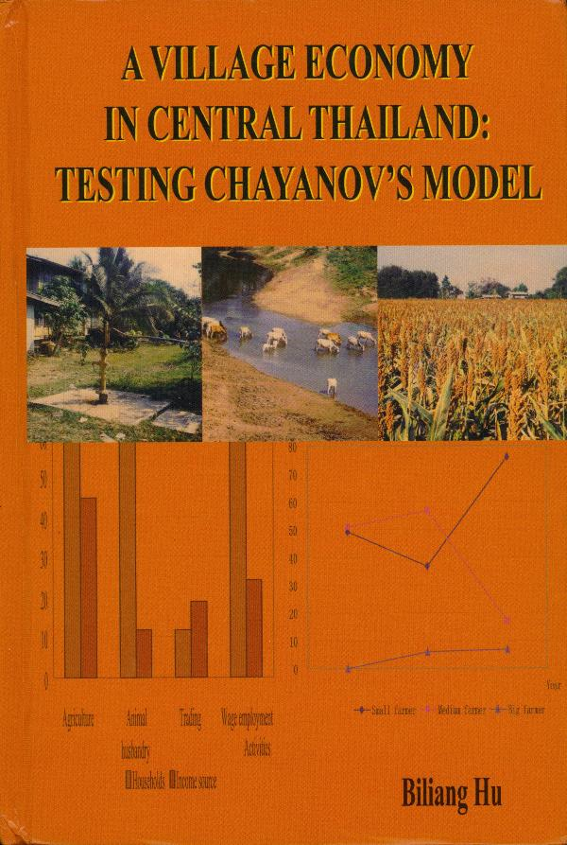

A VILLAGE ECONOMY IN CENTRAL TAILAND:
TESTING CHAYANOVE’S MODEL

Biliang Hu
Thai Watana Panach Press Co., Ltd.

July 2007
The study aims at testing the hypotheses of classic theory of Chayanov’s peasant economy by focusing on its characteristics．For this purpose，the data required has been gathered through a sample survey of a village in central Thailand．The conceptual framework of the economic organization of the peasant family household is also discussed in the study．The result of the study shows that a great difference exists between the doctrines and the reality seen in the Thai village．The study also provides some explanations of the reasons from the theoretical point of view．As part of the study，suggestions on how to improve the existing situation of the village to meet the people’s further needs and how to develop the framework of peasant economies a1ong with the rapid change of reality of the world from the theoretical perspective are proposed．

