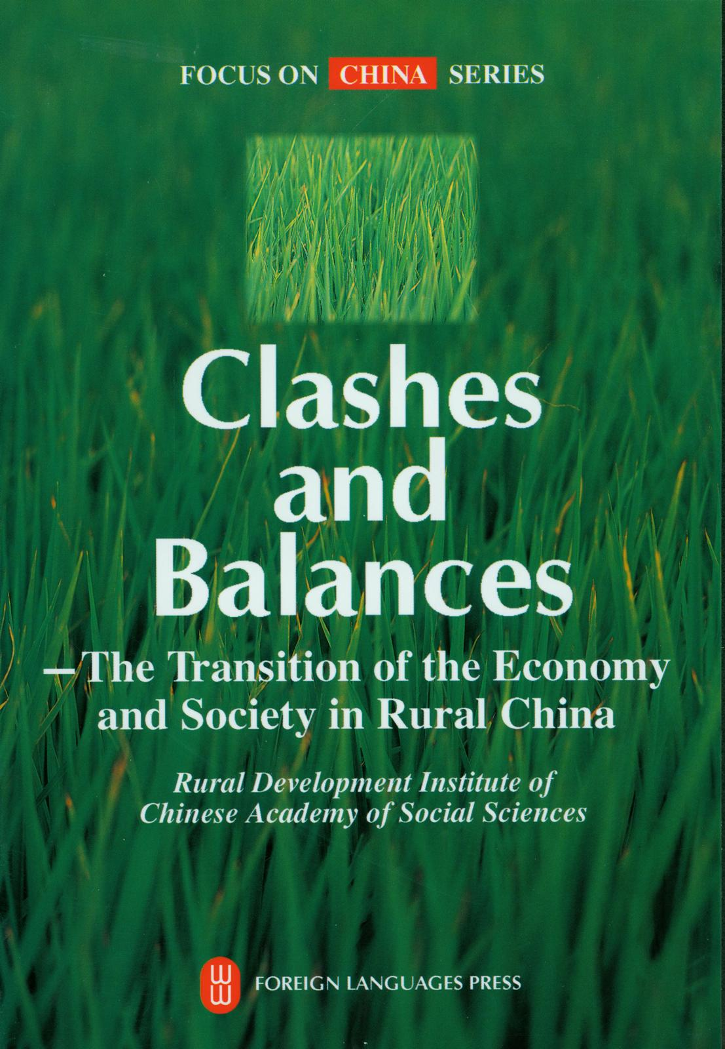
Foreword

As I understand it, many foreigners know very 1ittle about China．Even intellectuals in developed countries do not know much about China．Those who do know about China are an extreme minority of specialists．This situation is by no means satisfactory．Today, as the entire human society is increasingly moving toward globalization，it will be a good thing for both Chinese and foreigners themselves if more foreigners gain an understanding Of China．It is our intention in writing this book to help those concerned with international affairs．particularly those concerned with the reform and development of China，to enhance their knowledge of the country．Of course，this book can only introduce one aspect of Chinese affairs,
i．e．, changes and developments in rural China in the last two decades．

China is a country with a huge population, of which a large percentage is rural people．During a period of about two decades，reform and development in rural China have been the most significant factor in the dramatic changes in the country．We have chosen Clashes and Balances for the title of this book in the hope of reflecting the complexities resulting from the violent adjustment of the relationships of interests that has taken place in rural China as well as the efforts the Chinese government has taken to deal with the contradictions Each author of the eight Chapters of the book is a specialist in the area he or she deals with．They try to present the changes from their observation in a way that is objective and easy to understand，and provide readers with information that is accurate and comments that carry weight．I hope readers will benefit from this book．

Dang Guoying，
Professor，Rural Development Institute，
Chinese Academy of Social Sciences
2005，Beijing

Authors

Chapter I Dang Guoying，professor, Rural Development Institute，Chinese Academy of Social Sciences
Chapter II Li Guoxiang，associate professor, Rural Development Institute，Chinese Academy of Social Sciences
Chapter III Li Yingchun，professor，Department of Economic Management，Sanming Institute of Fujian Province
Chapter IV Zhu Gang，professor，Rural Development Institute， Chinese Academy of Social Sciences
Chapter V Li Hongyuan，professor，Rural Development Institute，Chinese Academy of Social Sciences
Chapter VI Wang Xiujie，associate professor, Rural Development Institute，Chinese Academy of Social Sciences
Chapter VII Weng Ming，associate professor, Rural Development Institute，Chinese Academy of Social Sciences
Chapter VIII Dang Guoying，professor, Rural Development Institute，Chinese Academy of Social Sciences

Contents

Foreword 1
Chapter I Changes in the Rural Economic System in Modern China 3
Chapter II The Process of China’s Rural Economic Development 25
Chapter III Infrastructure in Rural China 50
Chapter IV The Fiscal System in Rural China 68
Chapter V Finance in Rural China 94
Chapter VI The Grain Market in China 121
Chapter VII Changes and Development of Foreign Trade
in Agricultural Produce in China 143
Chapter VIII Political Development in Rural China 159

