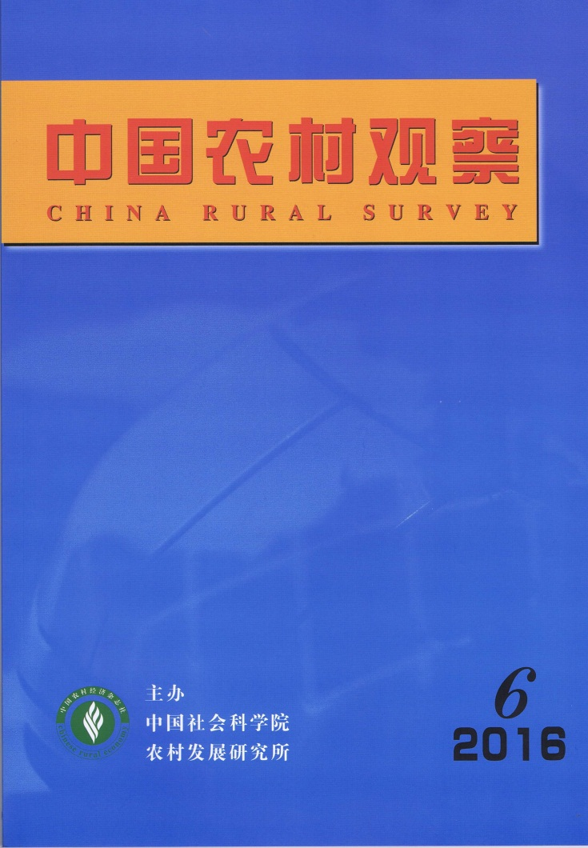
MAIN CONTENTS

The Internalization Paradox in Rural Micro-finance: A Case Study
……………………………………………………………………Gao Jun,Liu Yahui&Wen Tiejun（2）
This article explores two paradoxes that attribute to the development plight of rural micro-finance. On the one hand, informal rural micro-finance institutions are found to suffer from a loss in efficiency after the implementation of formal requirements, which can be called “legalization paradox” in the previous studies. The other paradox forms when “elite capture” becomes apparent in the implementation of public supporting policies in farmers' cooperative organizations. This study examines an example of SY Mutual Fund, and finds that while this cooperative micro-finance organization has successfully reduced transaction costs, it failed to internalize external risks which may lead to the dissolution of cooperation. To conclude, the study proposes that two paradoxes can be solved by way of organizational innovation and institutional innovation on the basis of rebuilding the cooperative system.
Entry Threshold for Rural Financial Institutions, Financial Inclusion and Income Distribution
………………………………………………………Zhang Xiaoyun,Fan Xiangmei&Xin Haibing（12）
In 2006, the China Banking Regulatory Commission (CBRC) has issued a document to ease the entry threshold for rural financial institutions in several ways. This article analyzes the impact of this policy on income distribution in rural areas in an empirical way. The study finds that the relaxation has promoted financial inclusion in rural areas, effectively enhanced the income level of low-income groups, and significantly reduced income inequality in rural areas. Furthermore, the article finds that the relaxation of market entry conditions has affected rural income distribution mainly through the following channels, namely, rural residents’ employment, occupational choice (by way of an increase in self-employment) and the transfer of land management rights.
Credit Access, Financing Scale and Farmer Households’ Land Transfer: An Analysis on Specialized Farmers…………………………………………………………………Hou Jianyun&Huo Xuexi（29）
The Risk and Violation in Rural Credit Markets
…………………………………………………………………………Zhang Longyao&Wang Qi（40）
Farmlands’ Large-scale Management and the Re-stratification in Rural Society: The Sociological Proposition about Cultivating New Agricultural Business Entities
……………………………………………………………………Zhao Xiaofeng&Zhao Xiangyun（55）
This article compares three typical cases of agricultural land scale management. It finds that multiple actors have different resource endowments. For sake of having complementary advantages, different actors are found to form a complex relationship network of “absorption-attachment”, which results in social re-stratification and reconstruction in rural society. This re-stratification is expressed in two different forms. With regard to scale operation in agricultural production, ordinary farmers are found to stand in a weak position in an accelerating process of social re-stratification. With regard to scale operation in agricultural service, rural elites have become the main actors in services provision, and ordinary farmers as the main actors in agricultural production. The benefits are shared by multiple actors. The latter form thus indicates that the mode of small-scale production still has its development potential, and scale operation in agricultural service is found to be in accordance with China's national condition at the current stage.
he Development of Rural Governance Models and Recent Innovations
…………………………………………………………………………………………Liu Jinhai（67）
Although villagers’ self-governance is the basic institution in rural China, diversified models of rural governance have been witnessed in recent years. This article analyzes the development of three new social forces in rural governance in addition to "1+N" governance model and horizontal separation of powers, namely, natural villagers’ groups, clan authorities and other civil organizations etc. These three types of social forces have played different roles in the process of governance, forming different governance models including the general model, the development model and the innovation model. The article concludes that the diversity of rural governance models has further promoted the development of rural governance by highlighting villagers’ rights and status.
Agriculture Production Mode Reform Promoted by Internet plus: A Marxist Political Economy Perspective ………………………………………………………………………Zhou Shaodong（75）
Classical Marxism proposes agricultural modes of production to be divided into peasant mode of production, capitalist mode of production and socialist mode of production. Owing to the difficulties in the process of socialized production, peasant mode of production was not able to transform into capitalist mode of production as predicted. Based on the concepts of forces of, mode of and relations of production, this article focuses on the strategy of “internet plus” in reforming mode of production in agriculture. The conclusions of the study lie in three aspects. Firstly, the strategy of “internet plus” has changed the binding mode between laborers and means of production. It proves to be conducive to solving the problem of labor supervision. Secondly, it can improve agricultural scale operation in household production. Thirdly, it helps agriculture production to realize process specification and vertical division of labor. It is projected that the development direction of the socialist mode of agricultural production will follow a new production mode which exceeds peasant mode of production, and which proves to be different from the capitalist mode from the perspectives of the production mode and land ownership.
A Political Economy Analysis on “Renting a Piece of Mountain Land for Afforestation”: The Wisdom of Forestry Production from the Miao Territory in the Qing Dynasty
…………………………………………………………………………………………Li Xiangyu（86）

CHINA RURAL SURVEY (CRS) is published bimonthly by Rural Development Institute of Chinese Academy of Social Sciences.
Editor in Chief：Wei Houkai Deputy Editor in Chief：Du Zhixiong & Pan Jin
Address：No.5, Jianguomennei Ave., Beijing, 100732, China
Code No.BM4476 Overseas Distributor：China International Book

