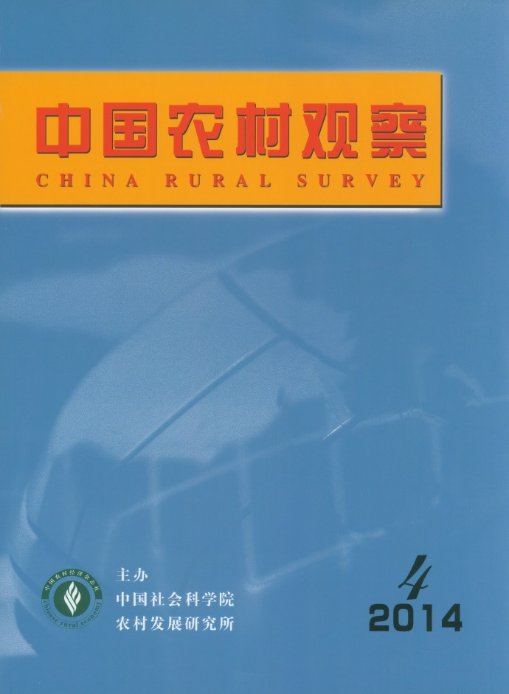

MAIN CONTENTS
Structural Characteristics and Determinant Factors of the Demand of the Elderly for Social Care Services
——Based on the Analysis on the Replacement Mechanism of Family Supporting for the Elderly
…………………………………………………………………………Tian Beihai & Wang Caiyun（2）
The social care services root in the weakening of family supporting systems for the elderly. As a consequence, the demand of the elderly for social care services is determined by the substitutability of family supporting for the elderly to some extent. From the perspective of embeddedness, the article interprets the replacement mechanism of family support for the elderly theoretically and analyzed the characteristics and determinant factors of the demand of the elderly for social care services empirically. The research results show that the demand level of the elderly for social care services is low in general, while the demand level for health and medical care and mental console is relatively high. Physical function acts as the hard constraint factor on the demand of the elderly for social care services. The weaker the physical function is, the higher the demand level of the elderly for social care services is. The demand of the elderly for social care services is embedded in the family structural situation, which means that, the aged who live in families with more family members, less generation, less sons and more family members who graduated from colleges, tend to have higher demand level for social care services. Meanwhile, the aged who live without spouse tend to have higher demand level for social care services. Attribute to the self-enforcement effect of current care pattern for the elderly, the aged who live in the elderly support organizations such as Yanglaoyuan (Residential Long-term Care) tend to have higher demand level for social care services. The research results indicate that, the demands of the oldest-old with weak physical function for social care services are rigid and practical. So it’s a task of top priority to construct a social care service system, which is based on reinforcing the core position of home-based care for the elderly and focuses on the need of the oldest-old and the widowed old.

Research on Subject Well-being of the Elderly in Rural Area and its Impact Factors
——Based on the Case Study of Shandong, Henan and Shanxi Province
…………………………………………………………………………… Li Yue & Cui Hongzhi（18）

Demand Evaluation of Social Old-age Service: Base on the Survey of 1051 Rural Elderly People in Jiangsu
…………………………………………………………… Huang Junhui, Li Fang & Zhao Guang（29）

How Contract Duration be Determined？
——Based on Empirical Analysis from Dimensions of Asset Specificity
…………………………………………………………………… Zhong Wenjing & Luo Biliang（42）
The farmland’s functions of welfare guarantee and economical value, express the importance of its assets attribute to transfer contracting. This article focused in discussing the determinations of contract duration when rural households lease farmland. Based on empirical analysis, it is find that the determinations of contract duration is related to households’resource endowment, but has merely relation to farmland’s valuable attribute of property rights. The article emphasizes that farmland is personhood property to rural household. So, empower farmland’s property right to rural households, what can improve the stability and normalization of farmland-transfer-contract.

The Practice of the Right to Use House Sites and Rethinking of the Changing Discourse of the Highly
Proprietarized Countryside Homestead System’s Reformation
——The Analysis from the Perspective of Social Property Rights
………………………………………………………………………………………………Yin Zi（52）

A Research about Effects of Agricultural Technology Diffusion Power and Channel Operation on Farmers’
Production Efficiency
——Based on the Data of Henan Wheat Planting Area
……………………………………………………………… Chang Xiangyang & Han Yuanyuan（63）
The paper analyzed the effects of agricultural technology diffusion power and channel operation on farmers’production efficiency by using structural equation model. The data came from the survey in the wheat planting area of Henan Province. The results show that: Government power and market power have direct positive impacts on agricultural production efficiency. They also have indirect impacts by agricultural technology diffusion channel operation. Agricultural technology diffusion channel organizing, supporting and controlling have positive effects on farmers’production efficiency. Agricultural technology diffusion channel operation has mediating effect between the power factor and the farmers' production efficiency.

Empirical Analysis on the Relationship among System Efficiency, Professional Satisfaction and
Professional Loyalty: Based on the Investigation of Grass-root Agricultural Technicians in 10 Counties
of Hubei Province
………………………………………………………………… Gong Jihong & Zhong Zhangbao（71）

The Demand Willingness of Agricultural Techniques of Self-employed Rural Women and its Factors:
Taking Agricultural Waste Substrate Industrial Techniques as the Example
…………………………………………………………… He Ke, Zhang Junbiao & Feng Junhui（84）

CHINA RURAL SURVEY (CRS) is published bimonthly by Institute of Rural Development of Chinese Academy of Social Sciences.
Editor in Chief：Li Zhou
Deputy Editor in chief：Du Zhixiong Address：No.5, Jianguomennei Ave.，Beijing, 100732, China
Code No.BM4476 Overseas Distributor：China International Book

