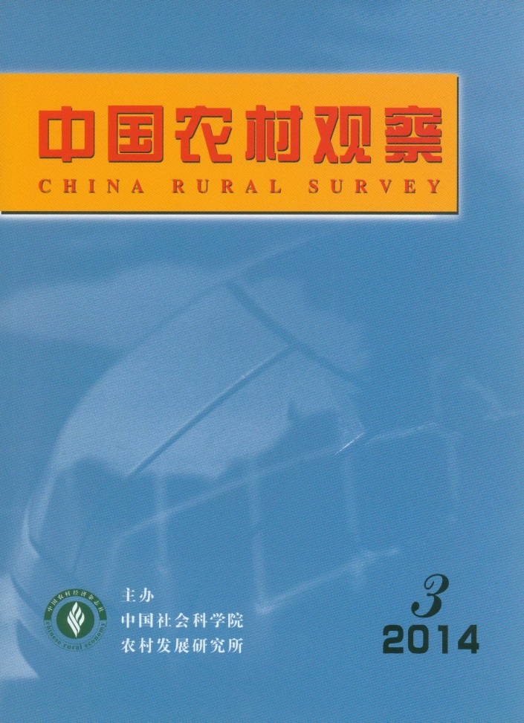
MAIN CONTENTS
Farming Experience, Education Level, and Job Choice of New Immigrant Workers
——A study of frictional unemployment among new generation immigrant workers
………………………………………………………………………Zhong Funing & Chen Yishan（2）
An Empirical Study on Migrant Workers’ Willingness and Behavior of Participation in the Rights Protecting Organizations
——Based on the Survey Data Collected in the cities of Fuyang and Shenzhen
…………………………… Huang Shengnan, Liu He, Yao Bing, Wang Yalong & Wang Zhigang（10）
Entrepreneurial Ability, Rural Different Entrepreneurial Environment and Farmer’s Entrepreneurial
Performance
——An empirical analysis based on the rural survey data of 14 countries in three provinces
…………………………………………………………………… Zhang Yifeng & Zheng Xiuzhi（21）
The Impact of Dual Embeddedness of Social Network and Industrial Network, Resource Acquisition on
Entrepreneurial Capability of Migrant Workers
——A Empirical Analysis Based on the Survey Data of 183 Migrant Worker Entrepreneurs from
Jiangxi, Anhui and Jiangsu Province…………………Zhuang Jincai, Rui Zhengyun & Zeng Jifen（29）
Empirical Analysis on Microcosmic Determinants of Farmers’ Occupational Differentiation
——Based on Dual Perspective of Differentiation Degree and Differentiation Choice
between Urban and Rural Areas……………………………………… Li Yibo & Peng Jianqiang（42）
The Development of Village in the Process of Urbanization………………………… Chen Wensheng（52）
The Loss and Change of Rural Publicity: Concurrently Discuss the Effect of Community Service on
Developing Rural Publicity……………………………………………………………Wu Yemiao（57）
A Study on Rural Phenomenon of Keeping up with the Joneses under the Perspective of Social Comparison Theory
——Evidence from 10 villages of 3 cities，Shandong province………………………Lu Xianying（65）
"Acquaintance Society”: Experience View and Value Thought
…………………………………………………………………Liu Xiaofeng & Zhou Changcheng（73）
The Analysis of the Papers Published in the Journal of “China Rural Survey” in 1995～2013 and Their
Social Impacts………………………………………………………………………Chen Qiuhong（82）

CHINA RURAL SURVEY (CRS) is published bimonthly by Institute of Rural Development of Chinese Academy of Social Sciences.
Editor in Chief：Li Zhou
Deputy Editor in chief：Du Zhixiong Address：No.5, Jianguomennei Ave.，Beijing, 100732, China
Code No.BM4476 Overseas Distributor：China International Book

