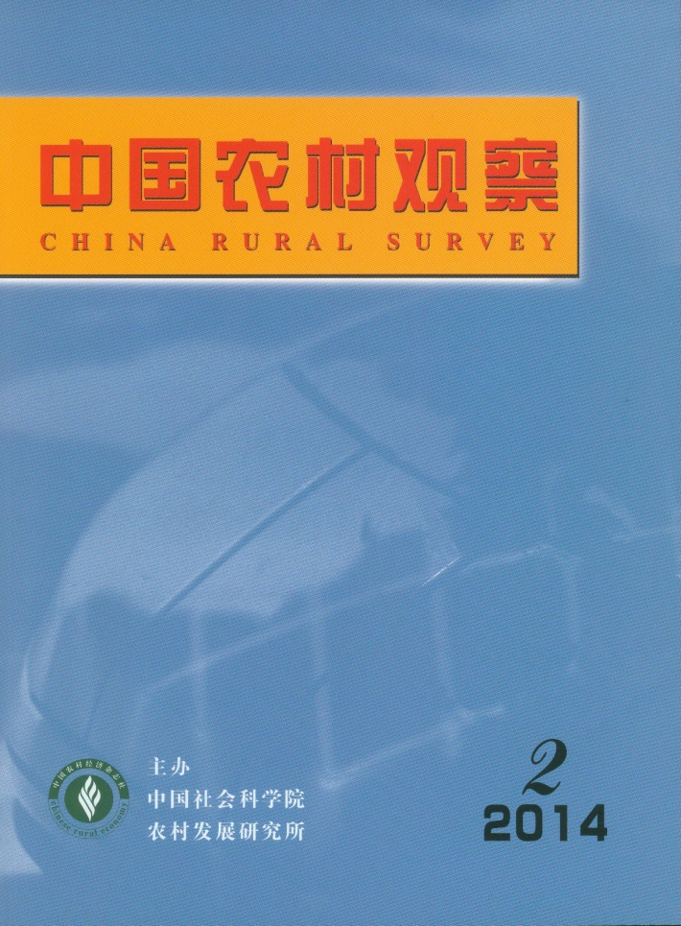
MAIN CONTENTS
Rural Logic of Farmer Cooperatives’ System Alienation
——Based on The Case Study of “Packing the Capital Inflowing the Rural ”
……………………………………………………………………………………………Feng Xiao（2）
Through analyzing the current phenomenon of “Farmer cooperatives packing the capital inflowing the rural(i.e. outside capital)”, the article found that the farmer cooperatives were packaged as the outside capital profit tools, the preferential policies package of government to attract outside capital to invest in villages and the carrier of village elite’s speculative capital. All these phenomena presented the departure status between cooperatives system and local practice and manifested the alienation of cooperative system. The operation of the cooperative system need adapt it to local social and political ecology. The current differentiation of rural social structure, changes in the way of grassroots governance and dynamic changes of rural economic development lead different combination forms of power and outside capital, such as the combination of government power and outside capital, the alliance of outside capital and the authority of violence in the countryside, and conspiracy of few village elite. So the farmer cooperatives were operated strategically by them，which constituted the rural logic of the alienation of cooperative system.

Research on the Impacts of Operation of Guanxi on Obtaining Exterior Resources for Specialized Farmers’
Cooperatives: Based on the Survey of 27 Cooperatives in Zhejiang Province
…………………………………………………………………………………………Yang Canjun（9）
This study divides the organizers of specialized farmers’ cooperatives into nengren organizers and cadre organizers. In this field study, we find that the cadre organizers obtain external resources from local governments by establishing and maintaining a two-way dependency relationship with the government in the production of farm products. In addition, cadre organizers actively expand sales channels and promote rapid development of cooperatives by taking advantage of the market clientelism and building partnerships with peers. In contrast, nengren organizers are one-way dependent on the government, which is a weak relationship, and are also competing with peers, eventually leading to the cooperatives exist in name only. Evidently, in a relationship-driven society like China, the operation of guanxi by organizers has a strong influence on the access of cooperatives to external resources. Further research is needed to examine how to fully utilize exterior resources and promote standardized development of cooperatives by standardizing and guiding the operation of guanxi.

An Analysis on the Formation Logic，Boundary and Nature of Farmer Cooperatives from Stakeholders’
Collective Choices Perspective………………………………………………Huang Shengzhong（18）
From stakeholders’ collective choices perspective, this paper analyzes the formation logic、boundary and nature of farmer cooperatives. The research shows that: the formation of farmer cooperatives is the results of stakeholders’ two collective choices. Just the two collective choices and the boundary of transactional contracts decide the boundary of farmer cooperatives. The nature of farmer cooperative is a nexus of relationship among stakeholders. To sum up，this paper brings forward the “The triangular frame”, which claims that it’s more suitable to use configuration approach to understand organizational characteristics of Chinese farmer cooperatives, and it’s more important to stress view “reach the same goal by different means”.

Study of the Relationship between Cooperatives and Two Committees in Village
………………………………………………………………………………………………Pan Jin（26）
There are different characteristics of the relationship between cooperatives and two committees in village in different types of cooperatives. In the cooperatives which village leaders are in charge, the leaders have diversified role identities, so there are diversified characteristics of the relationship between cooperative and two committees in village. In the cooperatives which village leaders are not in charge, the types of the relationship between cooperatives and two committees in village can be different, according to the function of the cooperative and the governing capacity of the two committees in village, which leads to their different action logics.

Research on Co-operational Relationships of Family Farms and Farmer Specialized Cooperatives
…………………………………………………………………………………………Wang Yong（39）
Building intensive，professional，organized and social new type of agricultural management system is an important agricultural policy at present. In this system, family farms and farmer specialized cooperatives are the important constituent parts. It's necessary to develop cooperation for them. Many countries take measures to support them for their weakness in market economic system. Practice has proved they can work together effectively. Building their co-operational relationships will be affected by multiple factors，such as the development degree of factor markets and agricultural products markets，property rights clarity. The government must earnestly fulfill their responsibility as the public goods provider，establish and improve the entry and exit mechanism of family farms and farmer specialized cooperatives，fully absorb the international experience，design the development policy of family farms and farmer specialized cooperatives with Chinese characteristics.

The Study of Food Safety Risk Assessment and Risk Characteristics in China during 2006-2012
………………………………………………………………………Zhu Dian & Hong Xiaojuan（49）
This study attempted to assess food safety risks in China during 2006-2012 at the macro level from the perspective of management using econometric models, taking full account of data availability and scientificity. The actual state of food safety risks was analyzed on this basis to provide a panoramic description of the main characteristics, changes, and trends of food quality and safety in China. Furthermore, the main characteristics of food safety risks were examined in terms of root causes, in order to identify the main focus in food safety risk management in China.

Consumers’ Food Safety Risk Perceptions and Willingness to Accept: Based on a Random nth-price
Auction…………………………………Wu Linhai, Zhong Yingqi, Hong Wei & Wu Zhihai Wu（60）
In this study, a real market environment was simulated via a random nth-price auction. Consumers’ willingness to accept orange juice containing additives in place of freshly squeezed orange juice, as well as the effects of positive and negative information of orange juice additives on consumers’ risk perceptions of food additives, was then examined using Tobit and multivariate linear models. Finally, three findings were obtained. a. Negative information of orange juice additives was given a higher weight by consumers; consumers with some knowledge about additives, rather than those without knowledge about additives, had a higher willingness to accept. b. Information processing capacity, concern about the health of themselves and their families, and the ability to foresee the consequences of information had an impact on consumers' willingness to accept. c. The initial bid had a significant anchoring effect on consumers' willingness to accept. Therefore, the most basis task in building the food safety risk communication mechanism is to eliminate consumers’ scares about food safety by disclosing timely and accurate information about food safety risks, preventing misguidance in food safety risks by the media, especially online public opinion about food, at the source, and employing different communication strategies based on the differences among consumer groups.
Empirical Research on the Motivations and Influencing Factors of Chinese Urban Residents Joining CSA:
From the Aspect of Comparison with Western Country Consumers
……………………………………………………………………………………………Yang Bo（73）
Based on investigation data, this essay analyzed the motivations and influencing factors of Zhengzhou residents joins in CSA, and then compared with western country consumers. The essay finds that the first three reasons of Zhengzhou residents joining CSA are acquiring organic agricultural products, acquiring pleasure from planting and low price, while reasons of western country consumers joining CSA are acquiring organic agricultural products, acquiring fresh products and support local agriculture. The essay also finds that trust of green agriculture products affects Zhengzhou residents join CSA but doesn’t affect western country consumers. Zhengzhou’s economy and consumption level makes the conclusion also reflect the average status of Chinese urban residents.

High-end Agricultural Products: Problems of the “Last One Kilometer” in Pricing and the Unbalanced
Supply Chain Development
——Empirical Analysis on “Wuchang Rice”
………………………………………………………………………Zeng Weijiong & Xu Licheng（84）
Similar to some ordinary agricultural products, problems of the “last one kilometer” in pricing and uneven profit distribution also exist in the supply chain of high-end agricultural products. Such problems are responsible for less motivation of peasants in farm production. Thus, the whole supply chain can be blocked. The paper takes “Wuchang Rice” as an example and analyzes the distribution of costs and interests in its supply chain by using field research data, proving the existence of the “last one kilometer” problem in pricing and the unbalanced supply chain development. Based on the empirical analysis, the paper concludes three reasons for unbalanced supply chain development of high-end agricultural products and raises corresponding policy suggestions.

CHINA RURAL SURVEY (CRS) is published bimonthly by Institute of Rural Development of Chinese Academy of Social Sciences.
Editor in Chief：Li Zhou
Deputy Editor in chief：Du Zhixiong Address：No.5, Jianguomennei Ave.，Beijing, 100732, China
Code No.BM4476 Overseas Distributor：China International Book

