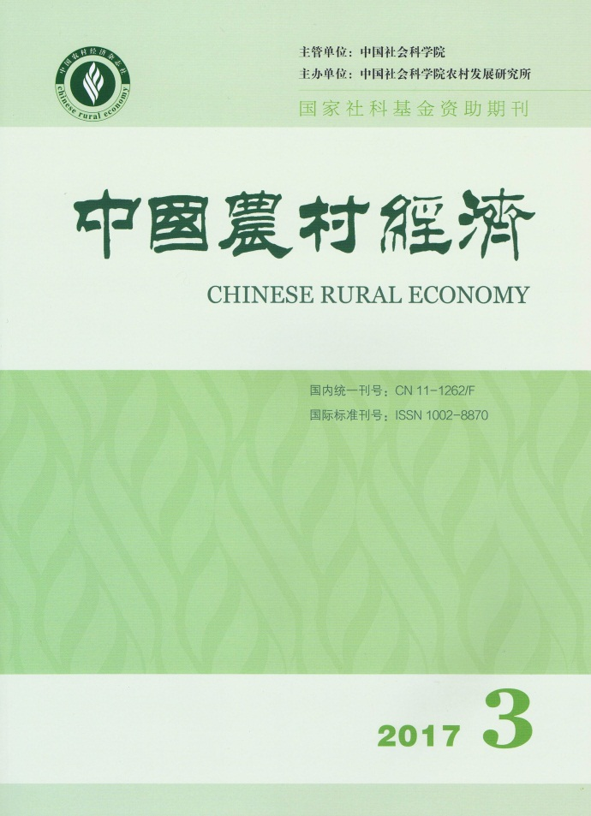
CHINESE RURAL
ECONOMY(Monthly) CONTENTS

No.3, 2017(Serial No.387)
Union Wage Effects on Rural Migrants: An Empirical Analysis by Using Propensity Score Matching
………………………………………………………………………………Li Long&Song Yueping（2）
Why are the New Generation of Migrant Workers Willing to Follow Status Consumption Behavior?: An Analysis from the Perspective of Urban Identity
……………………………………………………………Jin Xiaotong,Han Cheng&Nie Panpan（18）
The Effects of Farmers’ Adaptation to Climate Change on Agricultural Production: A Case Study on Apple Farmers in Shaanxi
…………………………………………Feng Xiaolong,Liu Mingyue,Huo Xuexi&Chen Zongxing（31）
An Analysis on the Logic and Trend of Regional Agricultural Factor Endowment Structure Change in China
………………………………………………………………………………………Luo Haoxuan（46）
The Dual Effects of "One Decision for Each Project" on Financial Rewards and Subsidies and its Coordination Mechanism
……………………………………………Zhou Mi,Zhang Guangsheng,Liu Hua&Wang Xiaorui（60）
The Effects of Farmers’ Going Upstairs on Famers’ Property Rights
……………………………………………………………………………………Zhang Mingming（74）
Corporate Governance, Ownership Property and Food Safety Information Disclosure
…………………………………………………………………………………………Chen Suyun（86）

Editor-in-Chief: Wei Houkai E-mail: ruraleconomy@cass.org.cn
Deputy Editor-in-Chief: Chen Jinsong Address: No.5, Jianguomen Nei Ave.,
Code No.M861 Beijing, 100732, China
Publisher: Chinese Rural Economy Publishing House Overseas Distributor: China International
Telephone: 0086-10-85195649 Book Trading Corporation
Fax: 0086-10-65137559 (P.O.Box 399, Beijing, China)

