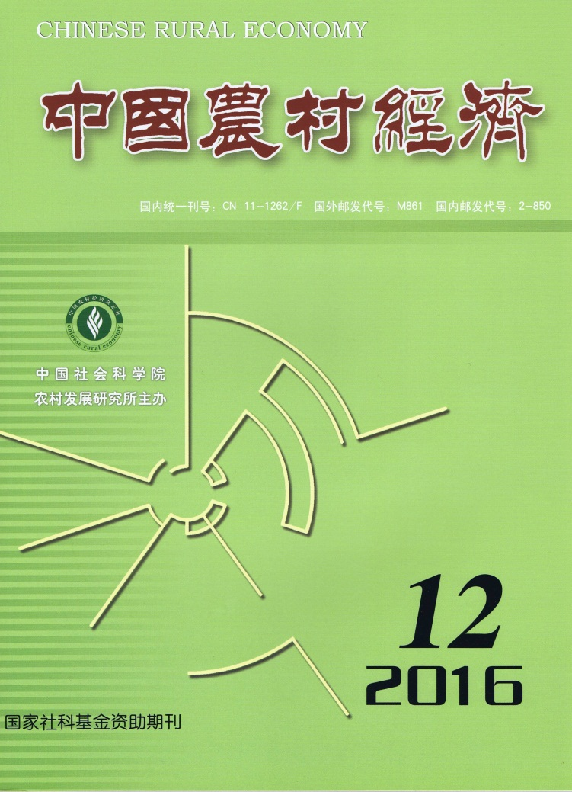

CHINESE RURAL
ECONOMY(Monthly) CONTENTS

No.12, 2016(Serial No.384)
Off-farm Employment, Land Transfer and Change in Agricultural Production Efficiency: An Empirical Analysis Based on CFPS
………………………………………………………………………Qian Long&Hong Mingyong（2）
An assessment of the Agricultural Subsidy Policy in China: Focusing on Incentive Effects and Wealth Effects……………………………………………………………………………………Li Jiangyi（17）
An Analysis of Ecological Consciousness of Family Farm Production Behavior and Its Influencing Factors:
An Empirical Test Based on Survey Data of Family Farms in China
…………………………………………………………………………Cai Yingping&Du Zhixiong（33）
The Influence of Agricultural Mechanization on Labor Substitution and Grain Production
………………………………………………………………Wang Ou,Tang Ke & Zheng Huamao（46）
Grain Logistics under Emergencies in China: A Decision Framework for Emergency Food Distribution
Based on Scenario Construction
……………………………………………Li Fengting,Hou Yunxian,Shao Kaili&Qian Xiangming（60）
Factor Endowment, Biased Technical Change and Agricultural TFP Growth in a Global Perspective:
A Comparative Analysis from 28 Countries
……………………………………………………………………………Fu Minghui&Qi Chunjie（76）

Editor-in-Chief: Wei Houkai E-mail: ruraleconomy@cass.org.cn
Deputy Editor-in-Chief: Du Zhixiong & Chen Jinsong Address: No.5, Jianguomen Nei Ave.,
Code No.M861 Beijing, 100732, China
Publisher: Chinese Rural Economy Publishing House Overseas Distributor: China International
Telephone: 0086-10-85195649 Book Trading Corporation
Fax: 0086-10-65137559 (P.O.Box 399, Beijing, China)

