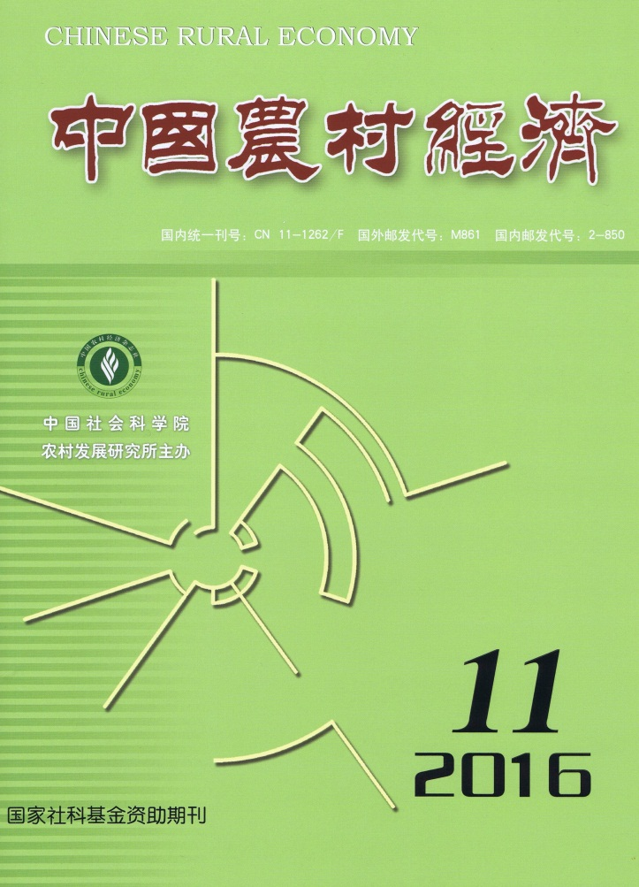
CHINESE RURAL
ECONOMY(Monthly) CONTENTS

No.11, 2016(Serial No.383)
Land Titling, Transaction Implications and the Shift in Agricultural Management Methods: The Expansion of the Coase theorem and Case studies…………………………………………………Luo Biliang（2）
Connotations, Essentials and Institutional Arrangements of Three Types of Land Tenure and Property Rights
……………………………………………………………………Xiao Weidong&Liang Chunmei（17）
Quality Measurement of China’s agricultural Exports: An Analysis with a Nested Logit Model
……………………………………………………………………Dong Yingguo&Huang Junwen（30）
Consumers’ Willingness to Pay for Traceable Food Attributes: The Case of Pork
………………………………………………Ying Ruiyao,Hou Bo,Chen Xiujuan&Chen Lingling（44）
An Analysis on the Potential for Carbon Sequestration in Chinese Forest Sector under China’s “New Normal”
……………………………………………………………………………Jiang Xia&Huang Zuhui（57）
The Impact of the New Rural Cooperative Medical Insurance and Health Human Capital on Labor Market
Participation in Rural China…………………………………………………Wang Yiqiu&Liu Lei（68）
Crop Insurance in the USA, Japan, and Canada: A Comparative Analysis
………………………………………………………………………………………Zhang Yuhuan（82）
Xi jinpings’ Ideas on Agriculture, Rural Areas and Farmers: A Summary of a Symposium
………………………………………………………………………………………Wang Jinhua（91）

Editor-in-Chief: Wei Houkai E-mail: ruraleconomy@cass.org.cn
Deputy Editor-in-Chief: Du Zhixiong & Chen Jinsong Address: No.5, Jianguomen Nei Ave.,
Code No.M861 Beijing, 100732, China
Publisher: Chinese Rural Economy Publishing House Overseas Distributor: China International
Telephone: 0086-10-85195649 Book Trading Corporation
Fax: 0086-10-65137559 (P.O.Box 399, Beijing, China)

