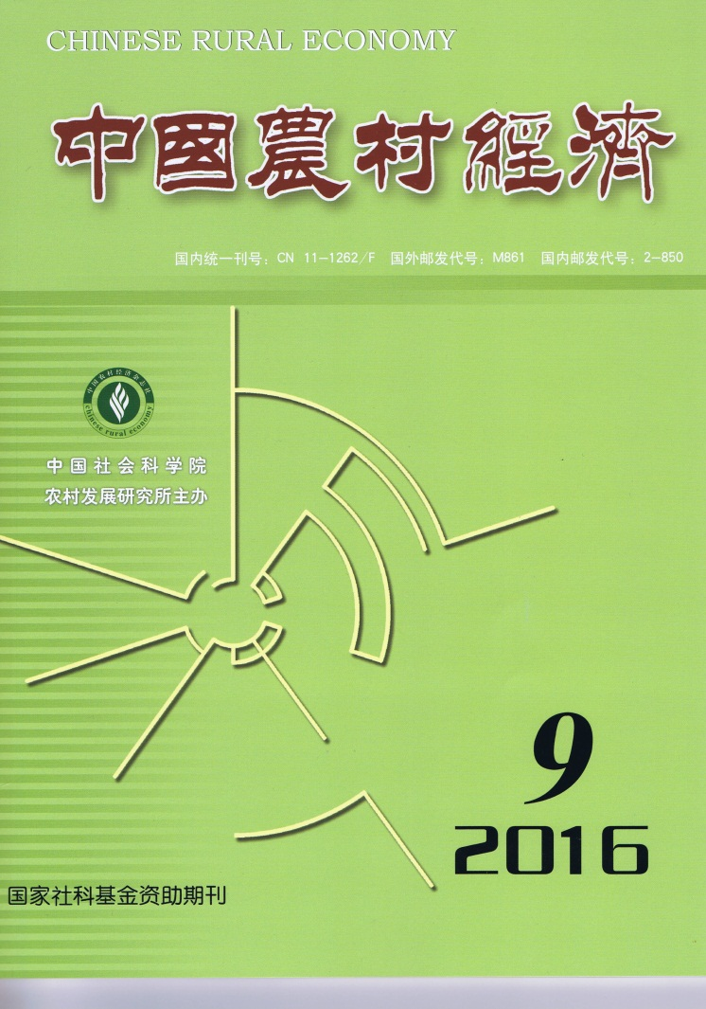

CHINESE RURAL
ECONOMY(Monthly) CONTENTS

No.9, 2016(Serial No.381)
Capital Dilemma and Breakthrough Path of China’s Urban-rural Development Integration: An Analysis
Based on Theory of Three Capital Circuits of Western Marxism
……………………………………………………………Long Qimeng, Fu Hongyuan & Liao Yan（2）
Rural Household Differentiation, Generational Gap and Rural Households’ Acceptance of Rural House Mortgage Loan ………………………………Liu Yanzhou, Wang Fang, Guo Yan & Song Delang（16）
Identification of the Agricultural Economic Cycle in China: 1978-2014……………………………………
……………………………………………………………………………Sui Jianli & Cai Qiyao（30）
The Contribution of Agricultural Labor Transfer to Non-agricultural Sectors to China’s Economic Growth: 1953-2015……………………………………………………………………………Hao Daming（44）
Adoption and Diffusion of Agricultural Innovations: Perspective of Social Network
……………………………………………………………………………………………Zhu Yueji（58）
A New Challenge of Agricultural Environment to Grain Revenue
——A Case Study of the Impact of Surface Ozone Pollution on Winter Wheat Production
…………………………………………………………………Yang Yongbing, Yi Fujin & Hu Hao（72）
The Insurance Mechanism of Dairy Safety Net in USA
……………………………………………………………………………………………Xia Yiguo（83）

Editor-in-Chief: Wei Houkai E-mail: ruraleconomy@cass.org.cn
Deputy Editor-in-Chief: Du Zhixiong & Chen Jinsong Address: No.5, Jianguomen Nei Ave.,
Code No.M861 Beijing, 100732, China
Publisher: Chinese Rural Economy Publishing House Overseas Distributor: China International
Telephone: 0086-10-85195649 Book Trading Corporation
Fax: 0086-10-65137559 (P.O.Box 399, Beijing, China)

