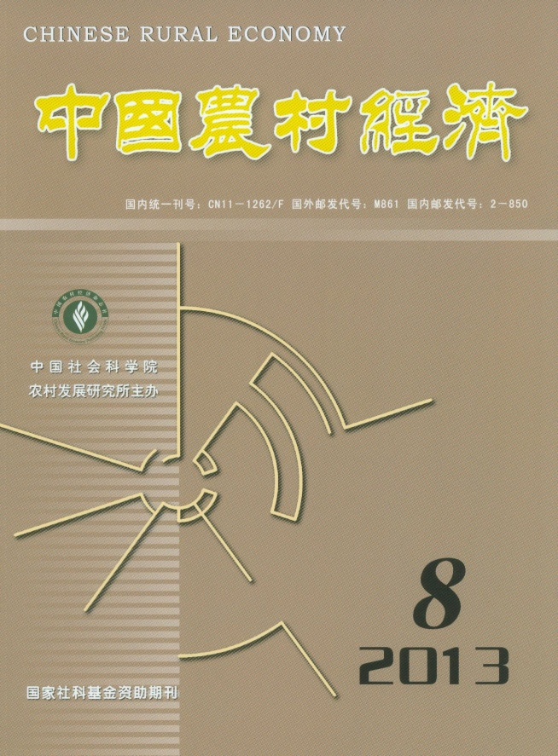

CHINESE RURAL
ECONOMY (Monthly) CONTENTS

No.8, 2013(Serial No.344)

The Achievements in China’s Rural Development and Challenges Confronted……………… Li Zhou（4）
An Analysis of the Determinants to Virtual Water Consumption of Agricultural Products in China
——Based on Dynamic Spatial Panel Data STIRPAT Model with Province-level Data………………
…………………………………………………Liu Hongmei, Deng Guangyao & Wang Keqiang（15）
China’s Soybean Importing Market: Competition Structure and Market Power………………………………
………………………………………………………………………………Si Wei & Zhang Meng（29）
The Positioning of China’s Soybean Industry Development with Opening-up Perspective and Some
Enlightenments……………………………Research Team of the Center for Promotion of Agricultural
Trade, the Ministry of Agriculture of China（40）
A Re-estimation of Surplus Rural Labour Forces in China…………………………… Zhang Xinghua（49）
The Net Effect of Contribution of Training to the Return of Human Capital Investment of Rural Migrant
Workers
——An Estimation with Average Effect of Treatment on the Treated…………………Qu Xiaobo（55）
Rights and Well-being of Rural Migrant Workers
——An Empirical Study Based on Micro-data…………Liu Jing, Mao Xuefeng & Xiong Yanyan（65）
Social Network, Innovativeness of Entrepreneurial Opportunity and Performance of Farmer’s Start-ups
……………………………………………………………………Guo Hongdong & Ding Gaojie（78）
The Theory, Practice and Crisis of Microfinance……………………… Cheng Yukshing & Yu Dianmo（88）

Editor-in-Chief: Li Zhou e-mail: ruraleconomy@cass.org.cn
Deputy Editor-in-Chief: Du Zhixiong Address: No.5, Jianguomen Nei Ave.,
Code No.M861 Beijing,100732, China
Publisher: Chinese Rural Economy Publishing House Overseas Distributor:China International
Telephone:0086-10-85195649 Book Trading Corporation
Fax: 0086-10-65137559 (P.O.Box 399,Beijing, China)

